# DATA BASE CONNECTION DETAILS:

## MYSQL server details

* Pre-requisites

Debian server in open stack, here the debian server is X22114386Project IP: 87.44.4.70



* This server has MYSQL server already installed with

**Sudo nano /etc/mysql/mysql.conf.d/mysqld.cnf**

Bind-address – 0.0.0.0

* SSH connection details

Host-ip: 87.44.4.70

Port : 22



Ssh credentials for private key

* Work bench connection details

SSH connection method: standard TCP/IP over SSH

Hostname: 87.44.4.70:22

SSHUsername: debian

Password: new.pem key given below

Mysql hostname: 127.0.0.1

Mysql server port: 3306

Username: root

Password: root

* 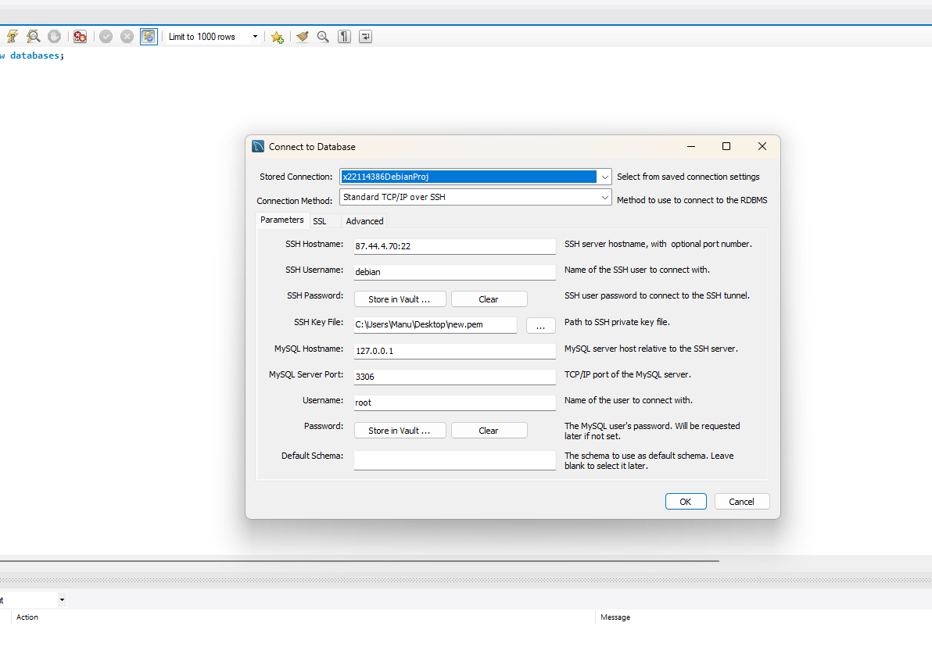
* 

# Postgress details:

 user = "dap",

 password = "dap",

 host = "87.44.4.70",

 port = "5432",

 database = "postgres